**LAPORAN PRATIKUM INTERNET OF THINGS (IOT)**

**IMPLEMENTASI MODEL TINYML UNTUK KLASIFIKASI DATASET IRIS MENGGUNAKAN ESP32**

**FAKULTAS VOKASI UNIVERSITAS BRAWIJAYA**

**Oleh**

*Maynanda Elisa Pasya T*

*Fakultas Vokasi, Universitas Brawijaya*

*Email:* [*maynandatbg@student.ub.ac.id*](mailto:maynandatbg@student.ub.ac.id)

**ABSTRAK**

TinyML merupakan pendekatan pembelajaran mesin yang dirancang untuk berjalan pada perangkat dengan sumber daya terbatas, seperti mikrokontroler. Penelitian ini mengimplementasikan model klasifikasi berbasis TinyML pada mikrokontroler ESP32 menggunakan dataset Iris sebagai studi kasus. Model dikembangkan menggunakan TensorFlow dan dikonversi ke dalam format TensorFlow Lite agar dapat diintegrasikan ke ESP32. Proses klasifikasi dilakukan langsung di perangkat tanpa koneksi ke cloud, sehingga memungkinkan inferensi secara cepat dan efisien. Hasil pengujian menunjukkan bahwa ESP32 mampu menjalankan model klasifikasi dengan akurasi tinggi dan waktu respon yang singkat. Implementasi ini menunjukkan potensi mikrokontroler dalam menjalankan tugas pembelajaran mesin secara lokal dan hemat daya.

**Kata Kunci:** TinyML, ESP32, Klasifikasi, TensorFlow Lite, Dataset Iris, Mikrokontroler

**ABSTRACT**

TinyML is a machine learning approach designed to run on resource-constrained devices such as microcontrollers. This study implements a classification model based on TinyML on the ESP32 microcontroller using the Iris dataset as a case study. The model was developed using TensorFlow and converted to TensorFlow Lite format for integration into the ESP32. The classification process is performed directly on the device without requiring a cloud connection, enabling fast and efficient inference. Testing results show that the ESP32 can run the classification model with high accuracy and short response time. This implementation demonstrates the potential of microcontrollers in performing machine learning tasks locally and energy-efficiently.

**Keywords:** TinyML, ESP32, Classification, TensorFlow Lite, Iris Dataset, Microcontroller

1. **PENDAHULUAAN**
   1. **Latar Belakang**

Kemajuan teknologi machine learning (ML) telah memberikan pengaruh signifikan terhadap komputasi pada perangkat tertanam. Salah satu pendekatan terbaru dalam penerapan ML adalah TinyML, yaitu teknik pembelajaran mesin yang dioptimalkan agar dapat dijalankan secara efisien pada perangkat dengan kapasitas terbatas seperti mikrokontroler.

Salah satu contoh dataset yang populer untuk tugas klasifikasi adalah dataset Iris. Dataset ini sangat sesuai digunakan sebagai studi kasus dalam penerapan TinyML. Dengan menggunakan mikrokontroler ESP32 dan TensorFlow Lite for Microcontrollers, proses klasifikasi dapat dilakukan langsung di perangkat tanpa perlu mengandalkan koneksi ke server eksternal. Pendekatan ini memungkinkan pengembangan aplikasi yang responsif, efisien, dan hemat energi.

* 1. **Tujuan Pratikum**

Bertujuaan untuk:

* Mengimplementasikan model klasifikasi berbasis TinyML pada mikrokontroler ESP32.
* Menggunakan dataset Iris sebagai data pelatihan dan pengujian model klasifikasi.
* Mengintegrasikan model yang telah dilatih ke dalam perangkat ESP32 menggunakan TensorFlow Lite.
* Menguji hasil klasifikasi secara langsung melalui serial monitor atau perangkat output lain.

1. **METODOLOGI**
   1. **Alat dan Bahan**
      1. **Perangkat keras:**

* ESP32 Development Board
* Kabel USB Micro
* Laptop/PC
  + 1. **Perangkat lunak:**
* Python (dengan library: scikit-learn, numpy, tensorflow)
* TensorFlow Lite
* Arduino IDE (dengan board ESP32 dan library TFLite Micro)
* Thonny IDE / Serial Monitor
  + 1. **Dataset:**
* Iris Dataset (dari sklearn.datasets.load_iris)
  1. **Langkah Implementasi**

1. Persiapan Dataset dan Model Machine Learning
2. Load dataset Iris menggunakan sklearn.datasets.
3. Lakukan preprocessing dan pembagian data (training dan testing).
4. Latih model klasifikasi menggunakan model sederhana seperti Decision Tree atau Neural Network.
5. Konversi model ke format TensorFlow Lite (.tflite), kemudian ke format C-array (.h) agar bisa digunakan di ESP32.Konfigurasi dan Coding ESP32
6. Siapkan Arduino IDE dengan board support untuk ESP32.
7. Instal library TensorFlowLite_ESP32 atau TFLite Micro.
8. Import model ke dalam sketch ESP32.
9. Buat fungsi input untuk menerima 4 fitur Iris (sepal length, sepal width, petal length, petal width).
10. Lakukan inferensi dan tampilkan hasil klasifikasi ke serial monitor.
11. Testing dan Validasi
12. Uji model dengan memasukkan nilai input secara manual melalui serial monitor.
13. Amati output apakah sesuai dengan prediksi kelas (Iris-setosa, versicolor, virginica).
14. **HASIL DAN PEMBAHASAN**
    1. **Hasil Implementasi di Visual Studio Code**

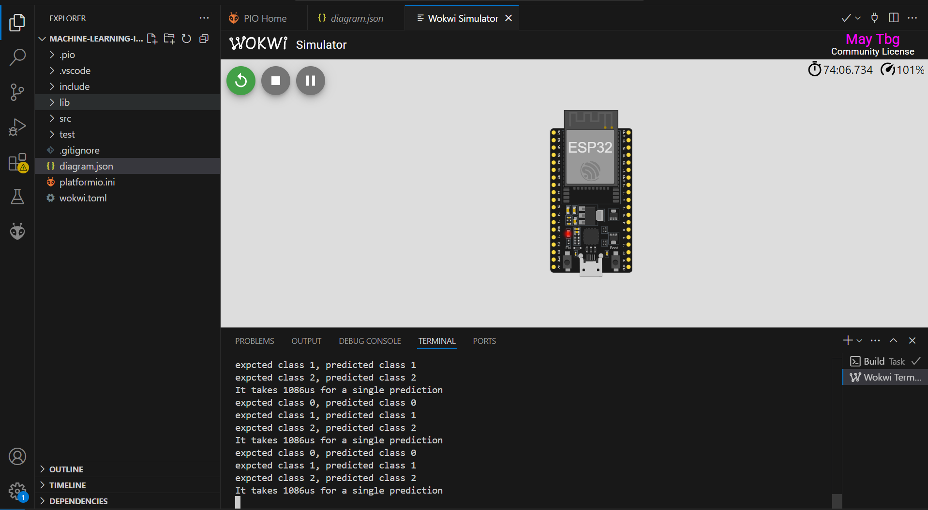

* 1. **Hasil Dataset**

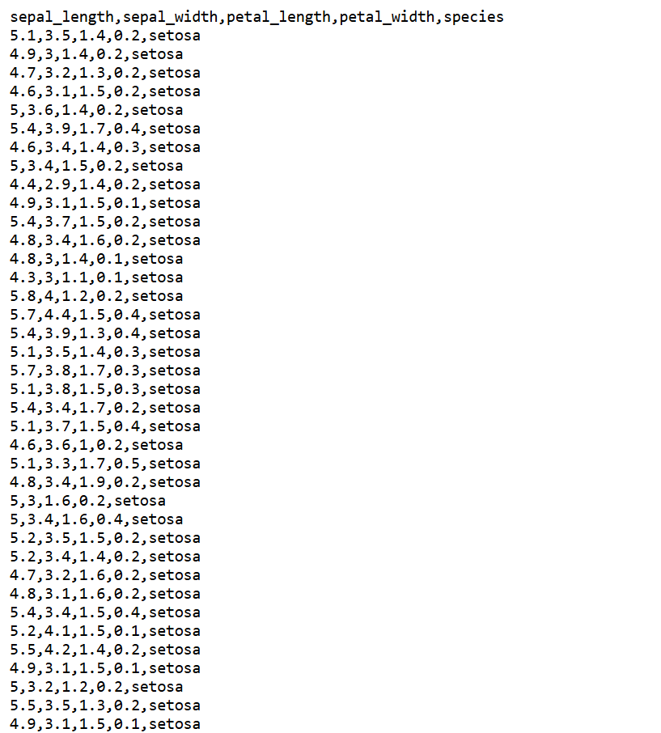

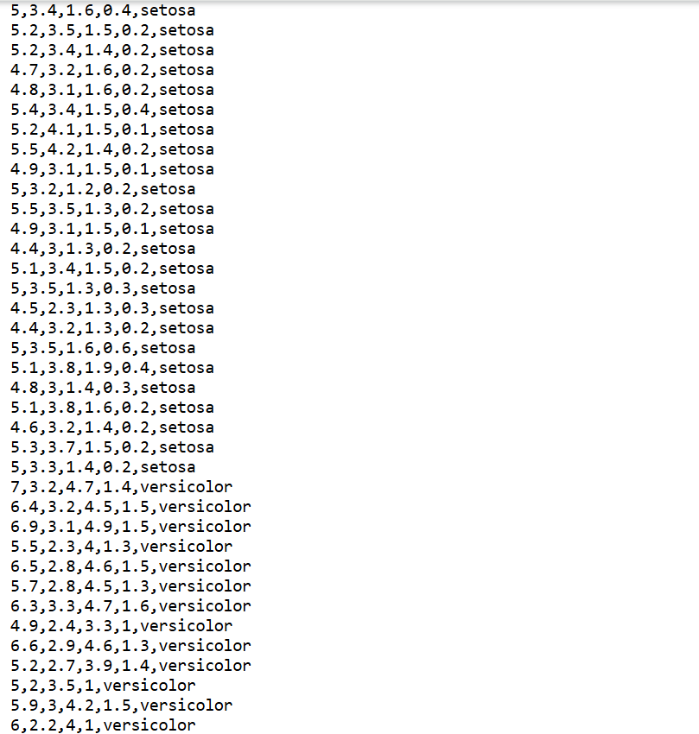

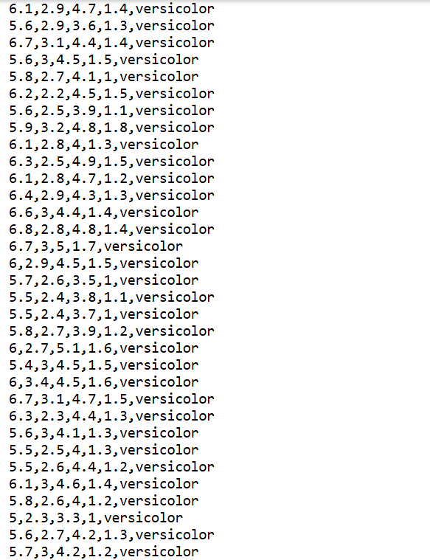

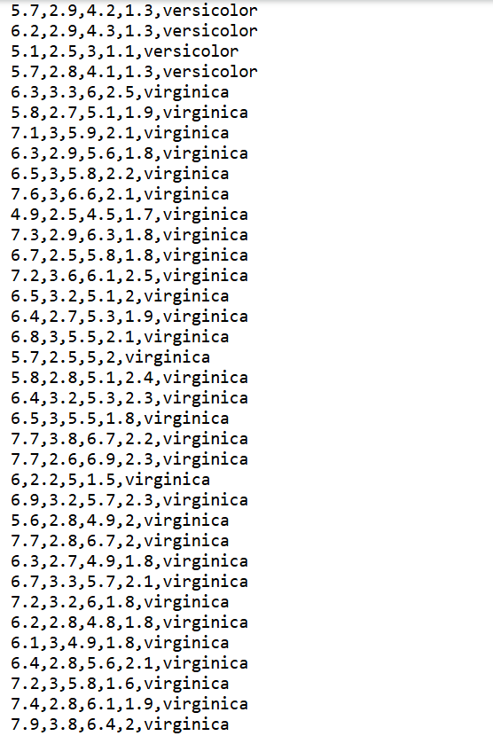

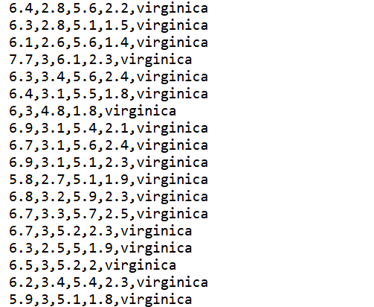

* 1. **Pembahasan**

Implementasi TinyML pada ESP32 menunjukkan bahwa mikrokontroler mampu menjalankan inferensi ML dengan sumber daya terbatas. Meskipun ukuran model harus disesuaikan (jumlah neuron dan layer harus minimal), hasil klasifikasi tetap akurat dan responsif.  
Kendala utama terletak pada konversi model dan integrasi header .h ke dalam program Arduino, yang memerlukan pemahaman format data dan penggunaan array byte. Selain itu, penting juga untuk mengoptimalkan ukuran model agar tidak melebihi kapasitas memori ESP32.

1. **LAMPIRAN**
   1. **Kode Program Main.cpp**

#include <Arduino.h>

/**

* Run a TensorFlow model to predict the IRIS dataset

* For a complete guide, visit

* https://eloquentarduino.com/tensorflow-lite-esp32

*/

// replace with your own model

// include BEFORE <eloquent_tinyml.h>!

#include "iris_model.h"

// include the runtime specific for your board

// either tflm_esp32 or tflm_cortexm

#include <tflm_esp32.h>

// now you can include the eloquent tinyml wrapper

#include <eloquent_tinyml.h>

// this is trial-and-error process

// when developing a new model, start with a high value

// (e.g. 10000), then decrease until the model stops

// working as expected

#define ARENA_SIZE 2000

Eloquent::TF::Sequential<TF_NUM_OPS, ARENA_SIZE> tf;

//Eloquent::TinyML::TfLite<4,3,ARENA_SIZE> tf;

/**

*

*/

void setup() {

Serial.begin(115200);

delay(3000);

Serial.println("_TENSORFLOW IRIS_");

// configure input/output

// (not mandatory if you generated the .h model

// using the everywhereml Python package)

tf.setNumInputs(4);

tf.setNumOutputs(3);

// add required ops

// (not mandatory if you generated the .h model

// using the everywhereml Python package)

tf.resolver.AddFullyConnected();

tf.resolver.AddSoftmax();

while (!tf.begin(irisModel).isOk())

Serial.println(tf.exception.toString());

}

void loop() {

// x0, x1, x2 are defined in the irisModel.h file

// https://github.com/eloquentarduino/EloquentTinyML/tree/main/examples/IrisExample/irisModel.h

// classify sample from class 0

if (!tf.predict(x0).isOk()) {

Serial.println(tf.exception.toString());

return;

}

Serial.print("expcted class 0, predicted class ");

Serial.println(tf.classification);

// classify sample from class 1

if (!tf.predict(x1).isOk()) {

Serial.println(tf.exception.toString());

return;

}

Serial.print("expcted class 1, predicted class ");

Serial.println(tf.classification);

// classify sample from class 2

if (!tf.predict(x2).isOk()) {

Serial.println(tf.exception.toString());

return;

}

Serial.print("expcted class 2, predicted class ");

Serial.println(tf.classification);

// how long does it take to run a single prediction?

Serial.print("It takes ");

Serial.print(tf.benchmark.microseconds());

Serial.println("us for a single prediction");

delay(1000);

}

* 1. **Kode Program diagram.json**

{

"version": 1,

"author": "rifcha sya’bani fatullah",

"editor": "wokwi",

"parts": [ { "type": "board-esp32-devkit-c-v4", "id": "esp", "top": 0, "left": 0, "attrs": {} } ],

"connections": [ [ "esp:TX", "$serialMonitor:RX", "", [] ], [ "esp:RX", "$serialMonitor:TX", "", [] ] ],

"dependencies": {}

}

* 1. **Kode iris_model.h**

#pragma once

#ifdef __has_attribute

#define HAVE_ATTRIBUTE(x) __has_attribute(x)

#else

#define HAVE_ATTRIBUTE(x) 0

#endif

#if HAVE_ATTRIBUTE(aligned) || (defined(_GNUC) && !defined(clang_))

#define DATA_ALIGN_ATTRIBUTE _attribute_((aligned(4)))

#else

#define DATA_ALIGN_ATTRIBUTE

#endif

// automatically configure network

#define TF_NUM_INPUTS 4

#define TF_NUM_OUTPUTS 3

#define TF_NUM_OPS 2

#define TF_OP_SOFTMAX

#define TF_OP_FULLYCONNECTED

// sample data

float x0[4] = {0.22222222222f, 0.62500000000f, 0.06779661017f, 0.04166666667f};

float x1[4] = {0.75000000000f, 0.50000000000f, 0.62711864407f, 0.54166666667f};

float x2[4] = {0.55555555556f, 0.54166666667f, 0.84745762712f, 1.00000000000f};

/** model size = 5048 bytes **/

const unsigned char irisModel[] DATA_ALIGN_ATTRIBUTE = { 0x1c, 0x00, 0x00, 0x00, 0x54, 0x46, 0x4c, 0x33, 0x14, 0x00, 0x20, 0x00, 0x1c, 0x00, 0x18, 0x00, 0x14, 0x00, 0x10, 0x00, 0x0c, 0x00, 0x00, 0x00, 0x08, 0x00, 0x04, 0x00, 0x14, 0x00, 0x00, 0x00, 0x1c, 0x00, 0x00, 0x00, 0x90, 0x00, 0x00, 0x00, 0xe8, 0x00, 0x00, 0x00, 0x88, 0x0d, 0x00, 0x00, 0x98, 0x0d, 0x00, 0x00, 0x54, 0x13, 0x00, 0x00, 0x03, 0x00, 0x00, 0x00, 0x01, 0x00, 0x00, 0x00, 0x10, 0x00, 0x00, 0x00, 0x00, 0x00, 0x0a, 0x00, 0x10, 0x00, 0x0c, 0x00, 0x08, 0x00, 0x04, 0x00, 0x0a, 0x00, 0x00, 0x00, 0x0c, 0x00, 0x00, 0x00, 0x1c, 0x00, 0x00, 0x00, 0x38, 0x00, 0x00, 0x00, 0x0f, 0x00, 0x00, 0x00, 0x73, 0x65, 0x72, 0x76, 0x69, 0x6e, 0x67, 0x5f, 0x64, 0x65, 0x66, 0x61, 0x75, 0x6c, 0x74, 0x00, 0x01, 0x00, 0x00, 0x00, 0x04, 0x00, 0x00, 0x00, 0x98, 0xff, 0xff, 0xff, 0x0a, 0x00, 0x00, 0x00, 0x04, 0x00, 0x00, 0x00, 0x07, 0x00, 0x00, 0x00, 0x64, 0x65, 0x6e, 0x73, 0x65, 0x5f, 0x32, 0x00, 0x01, 0x00, 0x00, 0x00, 0x04, 0x00, 0x00, 0x00, 0x5a, 0xf2, 0xff, 0xff, 0x04, 0x00, 0x00, 0x00, 0x0b, 0x00, 0x00, 0x00, 0x64, 0x65, 0x6e, 0x73, 0x65, 0x5f, 0x69, 0x6e, 0x70, 0x75, 0x74, 0x00, 0x02, 0x00, 0x00, 0x00, 0x34, 0x00, 0x00, 0x00, 0x04, 0x00, 0x00, 0x00, 0xdc, 0xff, 0xff, 0xff, 0x0d, 0x00, 0x00, 0x00, 0x04, 0x00, 0x00, 0x00, 0x13, 0x00, 0x00, 0x00, 0x43, 0x4f, 0x4e, 0x56, 0x45, 0x52, 0x53, 0x49, 0x4f, 0x4e, 0x5f, 0x4d, 0x45, 0x54, 0x41, 0x44, 0x41, 0x54, 0x41, 0x00, 0x08, 0x00, 0x0c, 0x00, 0x08, 0x00, 0x04, 0x00, 0x08, 0x00, 0x00, 0x00, 0x0c, 0x00, 0x00, 0x00, 0x04, 0x00, 0x00, 0x00, 0x13, 0x00, 0x00, 0x00, 0x6d, 0x69, 0x6e, 0x5f, 0x72, 0x75, 0x6e, 0x74, 0x69, 0x6d, 0x65, 0x5f, 0x76, 0x65, 0x72, 0x73, 0x69, 0x6f, 0x6e, 0x00, 0x0e, 0x00, 0x00, 0x00, 0x9c, 0x0c, 0x00, 0x00, 0x94, 0x0c, 0x00, 0x00, 0x44, 0x0c, 0x00, 0x00, 0x28, 0x0c, 0x00, 0x00, 0x98, 0x0b, 0x00, 0x00, 0x88, 0x09, 0x00, 0x00, 0x78, 0x01, 0x00, 0x00, 0xa8, 0x00, 0x00, 0x00, 0xa0, 0x00, 0x00, 0x00, 0x98, 0x00, 0x00, 0x00, 0x90, 0x00, 0x00, 0x00, 0x88, 0x00, 0x00, 0x00, 0x68, 0x00, 0x00, 0x00, 0x04, 0x00, 0x00, 0x00, 0x0a, 0xf3, 0xff, 0xff, 0x04, 0x00, 0x00, 0x00, 0x54, 0x00, 0x00, 0x00, 0x0c, 0x00, 0x00, 0x00, 0x08, 0x00, 0x0e, 0x00, 0x08, 0x00, 0x04, 0x00, 0x08, 0x00, 0x00, 0x00, 0x10, 0x00, 0x00, 0x00, 0x24, 0x00, 0x00, 0x00, 0x00, 0x00, 0x06, 0x00, 0x08, 0x00, 0x04, 0x00, 0x06, 0x00, 0x00, 0x00, 0x04, 0x00, 0x00, 0x00, 0x00, 0x00, 0x00, 0x00, 0x00, 0x00, 0x0a, 0x00, 0x10, 0x00, 0x0c, 0x00, 0x08, 0x00, 0x04, 0x00, 0x0a, 0x00, 0x00, 0x00, 0x02, 0x00, 0x00, 0x00, 0x02, 0x00, 0x00, 0x00, 0x04, 0x00, 0x00, 0x00, 0x06, 0x00, 0x00, 0x00, 0x32, 0x2e, 0x31, 0x35, 0x2e, 0x30, 0x00, 0x00, 0x6a, 0xf3, 0xff, 0xff, 0x04, 0x00, 0x00, 0x00, 0x10, 0x00, 0x00, 0x00, 0x31, 0x2e, 0x35, 0x2e, 0x30, 0x00, 0x00, 0x00, 0x00, 0x00, 0x00, 0x00, 0x00, 0x00, 0x00, 0x00, 0x78, 0xee, 0xff, 0xff, 0x7c, 0xee, 0xff, 0xff, 0x80, 0xee, 0xff, 0xff, 0x84, 0xee, 0xff, 0xff, 0x96, 0xf3, 0xff, 0xff, 0x04, 0x00, 0x00, 0x00, 0xc0, 0x00, 0x00, 0x00, 0xce, 0xe2, 0x15, 0xbf, 0xf8, 0xa5, 0x36, 0xbe, 0x3e, 0xea, 0xdb, 0xbe, 0x8f, 0x17, 0x36, 0xbe, 0xf5, 0xab, 0x05, 0xbf, 0xfc, 0xd5, 0xd4, 0x3e, 0xe0, 0xd2, 0x94, 0xbe, 0x98, 0xb6, 0xaa, 0xbe, 0x7d, 0x36, 0x66, 0xbe, 0x32, 0x06, 0x99, 0x3e, 0x87, 0xee, 0x2e, 0xbf, 0xe3, 0xcf, 0xac, 0x3e, 0x80, 0x10, 0x35, 0x3f, 0x58, 0x20, 0x21, 0x3f, 0x6f, 0xac, 0xfd, 0x3e, 0x2c, 0xa9, 0x9e, 0x3e, 0x5c, 0xcb, 0x15, 0x3e, 0x68, 0xd6, 0x90, 0xbe, 0x9d, 0x13, 0x83, 0xbe, 0x42, 0x9b, 0xbe, 0x3e, 0x78, 0x58, 0xe9, 0x3d, 0xf4, 0x62, 0x31, 0x3e, 0x9f, 0x8a, 0x66, 0xbe, 0x40, 0x86, 0xc6, 0xbd, 0x16, 0xec, 0x0a, 0x3d, 0x44, 0x7c, 0xb9, 0xbd, 0x16, 0x21, 0x03, 0xbf, 0x5f, 0x4b, 0x48, 0xbe, 0xc2, 0xc4, 0x07, 0x3e, 0xfb, 0x9f, 0x5f, 0xbe, 0x5f, 0x6b, 0xaa, 0xbe, 0x13, 0x07, 0x04, 0xbf, 0xde, 0x6c, 0x57, 0xbe, 0x0c, 0xc0, 0x10, 0x3f, 0x4a, 0x10, 0xdd, 0x3e, 0x08, 0x0f, 0xad, 0x3e, 0xd8, 0x76, 0xce, 0xbe, 0x20, 0xb8, 0xf1, 0xbc, 0xa8, 0x5e, 0xd9, 0x3e, 0xe2, 0xaa, 0xe2, 0x3e, 0x8b, 0xb6, 0xd7, 0x3e, 0xd8, 0xb5, 0xcd, 0xbe, 0x67, 0xba, 0x9b, 0x3e, 0x98, 0xc7, 0x37, 0xbf, 0x94, 0xef, 0x0f, 0xbf, 0x06, 0x21, 0x78, 0xbb, 0x41, 0x14, 0xfb, 0xbe, 0x8e, 0xa1, 0xdf, 0xbe, 0x62, 0xf4, 0xff, 0xff, 0x04, 0x00, 0x00, 0x00, 0x00, 0x08, 0x00, 0x00, 0x50, 0xe2, 0x80, 0x3d, 0xa8, 0x0f, 0x36, 0x3e, 0x33, 0x63, 0xb5, 0x3e, 0x67, 0x39, 0x58, 0xbe, 0x01, 0x13, 0x11, 0x3e, 0x03, 0x40, 0xad, 0x3e, 0x41, 0x64, 0xd7, 0x3d, 0x00, 0x92, 0x2d, 0xba, 0x72, 0x9f, 0xcf, 0x3e, 0x4c, 0x71, 0xb9, 0xbc, 0x74, 0xb1, 0x95, 0xbe, 0x52, 0x0d, 0xb6, 0x3e, 0xe0, 0x51, 0x87, 0x3d, 0xec, 0x17, 0x09, 0x3e, 0xf9, 0x22, 0xea, 0xbb, 0xb0, 0x80, 0x71, 0x3d, 0xe2, 0x8e, 0x91, 0xbe, 0x4e, 0x8b, 0x30, 0xbe, 0x31, 0xf8, 0x81, 0xbe, 0xf4, 0xa1, 0x0e, 0x3e, 0x44, 0xb6, 0x1e, 0xbe, 0xa3, 0xe2, 0xb9, 0xbe, 0x63, 0xe9, 0x5f, 0x3e, 0xcb, 0x9c, 0xa9, 0x3e, 0xaf, 0xe1, 0xb6, 0x3e, 0xfd, 0x21, 0x0e, 0xbe, 0x1a, 0xc7, 0x1e, 0x3e, 0xe7, 0xf4, 0xc7, 0x3d, 0x36, 0x2c, 0x7e, 0x3e, 0x51, 0x2d, 0xb2, 0x3e, 0x28, 0xb4, 0xcd, 0x3e, 0xe3, 0xbd, 0x1f, 0xbc, 0xc9, 0x41, 0xf4, 0xbe, 0x9f, 0x19, 0x3c, 0x3e, 0x95, 0xf2, 0x87, 0x3e, 0x7c, 0x01, 0xeb, 0xbd, 0xfe, 0xb6, 0x8e, 0x3e, 0x84, 0xc8, 0xd1, 0xbd, 0x41, 0xab, 0xf2, 0xbd, 0x50, 0x23, 0x5f, 0xbe, 0x42, 0xd7, 0x87, 0xbe, 0xa5, 0x8f, 0x44, 0xbe, 0x84, 0x19, 0xb6, 0xbd, 0x17, 0x47, 0xb7, 0x3d, 0xd0, 0x3d, 0x07, 0x3d, 0x3e, 0x92, 0x67, 0xbe, 0x16, 0xab, 0xaa, 0xbe, 0x7f, 0x89, 0xfc, 0xbe, 0x71, 0xb4, 0xb8, 0xbe, 0x89, 0x60, 0xcb, 0x3d, 0xd6, 0x45, 0xd1, 0xbe, 0xfb, 0x4e, 0xae, 0x3e, 0xa6, 0x40, 0x46, 0x3d, 0x02, 0x37, 0x97, 0xbe, 0x38, 0xad, 0x31, 0xbc, 0xd8, 0xaf, 0xd8, 0x3d, 0x6b, 0x25, 0x6b, 0x3e, 0x84, 0xa8, 0x5b, 0xbe, 0x1a, 0x7e, 0x06, 0x3e, 0x25, 0xaf, 0xa9, 0x3e, 0x08, 0x41, 0x66, 0xbd, 0x2f, 0xb8, 0xdf, 0x3e, 0x2f, 0x42, 0x3b, 0xbe, 0x83, 0xf3, 0xc9, 0x3e, 0x4e, 0xac, 0xd3, 0xbe, 0x7c, 0x54, 0x20, 0xbe, 0x14, 0xcc, 0x92, 0x3e, 0x6b, 0xaf, 0xac, 0x3e, 0x3e, 0x8e, 0x98, 0x3d, 0x48, 0x83, 0x6a, 0x3e, 0xb6, 0x60, 0x97, 0x3d, 0x70, 0xcf, 0x9f, 0xbd, 0x44, 0x0e, 0x4f, 0x3e, 0xc6, 0x2f, 0xf8, 0xbd, 0xa1, 0x3e, 0xb4, 0x3e, 0x0b, 0x2e, 0xcb, 0x3e, 0x15, 0xdf, 0x61, 0xbe, 0xea, 0xd2, 0x4e, 0x3e, 0xa9, 0xea, 0x7b, 0xbe, 0xf8, 0x23, 0x00, 0xbf, 0x4d, 0x79, 0x0d, 0x3e, 0x2d, 0x7a, 0x8b, 0x3e, 0x34, 0xc5, 0x10, 0xbf, 0xe8, 0xf7, 0x50, 0xbd, 0x74, 0x4a, 0x39, 0xbe, 0x9e, 0x99, 0x7b, 0x3d, 0x18, 0x13, 0x82, 0x3e, 0xa3, 0x55, 0x99, 0x3e, 0xf3, 0xc4, 0x10, 0x3e, 0x9d, 0xbc, 0xab, 0xbd, 0xba, 0x16, 0xaf, 0xbd, 0x07, 0xc5, 0xde, 0x3e, 0x39, 0xe9, 0x11, 0xbe, 0x40, 0xb9, 0xc6, 0x3e, 0xfe, 0x86, 0xa2, 0x3e, 0xb1, 0x63, 0x2c, 0x3e, 0x5f, 0x07, 0x0a, 0xbf, 0xbe, 0xc4, 0x9b, 0x3c, 0x50, 0x89, 0x2e, 0x3e, 0x7e, 0x37, 0x81, 0xbe, 0xd0, 0xef, 0xc2, 0x3e, 0xe6, 0x04, 0x4a, 0x3b, 0x34, 0x86, 0x25, 0x3e, 0xa7, 0x5e, 0x94, 0x3e, 0xaf, 0xeb, 0x0d, 0x3f, 0x4a, 0xfa, 0x75, 0x3e, 0xa8, 0xbb, 0x07, 0x3d, 0x4b, 0x5d, 0x1e, 0x3f, 0xad, 0x0f, 0x40, 0xbe, 0x71, 0x0f, 0x83, 0x3e, 0x0f, 0xa3, 0x80, 0xbe, 0x77, 0xb5, 0x01, 0xbf, 0x33, 0x3a, 0xed, 0xbe, 0x6a, 0x07, 0xd2, 0xbd, 0xa3, 0xda, 0xdf, 0x3d, 0x70, 0xe1, 0xa7, 0x3c, 0xb1, 0xb0, 0xdb, 0x3d, 0xdb, 0x5d, 0xb2, 0xbe, 0xea, 0x4f, 0xbf, 0xbe, 0x2f, 0x2e, 0xb8, 0x3e, 0xff, 0x6a, 0x12, 0x3e, 0x20, 0x18, 0x6b, 0x3e, 0x6b, 0x2a, 0x2f, 0x3f, 0x70, 0xb2, 0xc9, 0x3e, 0x7c, 0x76, 0xc5, 0x3d, 0xc2, 0x03, 0x02, 0x3e, 0xb5, 0xe5, 0xcf, 0x3d, 0x9f, 0xb2, 0x1f, 0xbe, 0xa5, 0xf4, 0xc0, 0xbe, 0x8c, 0xe1, 0x9f, 0x3d, 0x76, 0x6d, 0xa0, 0x3e, 0x47, 0x33, 0x82, 0x3e, 0xef, 0xaf, 0x19, 0x3e, 0x72, 0x7e, 0x70, 0x3e, 0xb3, 0x8d, 0x53, 0xbe, 0x8e, 0x41, 0x60, 0xbe, 0x21, 0x85, 0x9a, 0x3c, 0x59, 0xeb, 0x95, 0x3e, 0x60, 0x9f, 0x9a, 0xbe, 0x9d, 0x3b, 0xa3, 0x3e, 0x2a, 0x47, 0x25, 0x3e, 0xa8, 0x3b, 0x98, 0xbd, 0x25, 0x76, 0x1c, 0x3e, 0xd9, 0xb4, 0x82, 0xbe, 0x17, 0xec, 0xc4, 0xbd, 0xa1, 0xa8, 0x03, 0x3e, 0xf3, 0x79, 0x4e, 0x3e, 0x10, 0x50, 0xf3, 0x3d, 0x06, 0xdc, 0x95, 0x3e, 0xf7, 0x80, 0xbb, 0x3d, 0xdb, 0x39, 0x48, 0xbe, 0x64, 0xc4, 0x85, 0x3e, 0xf6, 0x60, 0x17, 0x3e, 0x38, 0xbd, 0x1c, 0x3e, 0x95, 0xab, 0xf1, 0x3c, 0xb9, 0xd2, 0x83, 0x3e, 0x84, 0x01, 0x86, 0xbe, 0x2e, 0xeb, 0x04, 0xbe, 0xd0, 0x7e, 0x16, 0xbe, 0x26, 0xa0, 0xc9, 0xbe, 0x08, 0x11, 0x2f, 0x3d, 0xc8, 0x8e, 0x4a, 0x3d, 0x5f, 0x53, 0x9a, 0xbe, 0x66, 0xd4, 0x84, 0xbe, 0x70, 0x3f, 0xb7, 0xbc, 0x9e, 0xcf, 0x2d, 0x3e, 0x0a, 0xc9, 0x89, 0xbe, 0xe7, 0x30, 0x82, 0x3e, 0xee, 0xd8, 0x06, 0xbe, 0x76, 0x91, 0x68, 0xbe, 0xe8, 0x97, 0x76, 0xbe, 0x6c, 0x81, 0xfd, 0xbd, 0x40, 0xc7, 0x72, 0xbd, 0xf0, 0x2e, 0x0b, 0xbd, 0x80, 0xd7, 0x06, 0x3b, 0x44, 0xd6, 0xcb, 0xbd, 0x60, 0xbc, 0xc4, 0xbc, 0x1e, 0x7e, 0xa2, 0xbe, 0x4e, 0xdc, 0x3e, 0xbe, 0x70, 0xee, 0x02, 0x3d, 0xa8, 0x2e, 0x2b, 0xbe, 0xee, 0x41, 0x04, 0xbe, 0xa5, 0xc0, 0x8d, 0x3e, 0x88, 0x44, 0x85, 0x3d, 0x67, 0x31, 0xac, 0x3e, 0xde, 0xd7, 0x31, 0x3e, 0x11, 0x20, 0xa6, 0x3e, 0x60, 0x27, 0x24, 0x3c, 0xe9, 0xdf, 0x89, 0x3e, 0xa2, 0x90, 0x50, 0x3e, 0xc7, 0x99, 0x88, 0xbe, 0x0f, 0x0a, 0x8c, 0x3e, 0x23, 0x8f, 0xac, 0xbe, 0xc7, 0xac, 0xa7, 0x3e, 0x2f, 0x28, 0x9c, 0x3e, 0x10, 0x07, 0x2a, 0xbe, 0x10, 0x91, 0xde, 0xbb, 0x47, 0x2f, 0xb9, 0xbe, 0xb9, 0x5b, 0x8d, 0xbc, 0xe6, 0x04, 0x1a, 0x3e, 0xe2, 0x3b, 0x85, 0xbe, 0x63, 0xe2, 0x3a, 0xbe, 0xf9, 0xac, 0x29, 0xbe, 0x7a, 0x9c, 0x2b, 0xbe, 0xae, 0x72, 0x90, 0xbe, 0x40, 0xdd, 0xbf, 0x3c, 0x18, 0x82, 0x87, 0xbe, 0x12, 0xb1, 0x23, 0xbe, 0x10, 0x1b, 0xbb, 0x3d, 0x95, 0x95, 0x06, 0x3e, 0x43, 0xbf, 0x92, 0x3e, 0x48, 0x12, 0x8c, 0xbe, 0x14, 0x3b, 0x87, 0xbe, 0xb8, 0xad, 0x54, 0xbe, 0x00, 0xfd, 0x2f, 0x3c, 0x8f, 0x9e, 0x85, 0xbd, 0x1a, 0xc5, 0x8e, 0xbe, 0xd2, 0x33, 0x02, 0xbe, 0x1e, 0x57, 0x2f, 0xbe, 0x30, 0xb2, 0x13, 0xbe, 0xfc, 0x85, 0x97, 0x3d, 0x05, 0xc6, 0x82, 0x3e, 0x37, 0xaf, 0x21, 0xbd, 0x4f, 0x32, 0x0f, 0x3d, 0x93, 0x7b, 0x77, 0xbe, 0x95, 0xba, 0x8c, 0x3e, 0xa8, 0x7e, 0x93, 0x3d, 0xad, 0x46, 0x5d, 0xbe, 0x5f, 0x90, 0x76, 0xbe, 0x14, 0x81, 0x8d, 0x3d, 0xbc, 0x3c, 0x8c, 0xbd, 0xc0, 0x3b, 0x4f, 0xbc, 0x66, 0x9c, 0xa9, 0xbe, 0x08, 0x27, 0x33, 0xbd, 0xca, 0x7e, 0x26, 0x3e, 0x10, 0x3b, 0xad, 0xbc, 0x96, 0xed, 0xd7, 0xbd, 0xf7, 0x8d, 0x86, 0x3e, 0xa4, 0x45, 0x82, 0xbe, 0xc8, 0xfa, 0x1a, 0x3d, 0x36, 0x92, 0x63, 0x3e, 0x0a, 0x3c, 0x3d, 0x3e, 0x36, 0x67, 0x10, 0x3e, 0x68, 0x9e, 0x58, 0x3d, 0x82, 0x51, 0x60, 0x3e, 0x3b, 0x98, 0x8a, 0xbe, 0x40, 0xb4, 0xa4, 0xbd, 0x38, 0x6f, 0xc1, 0x3d, 0x96, 0xb6, 0x83, 0xbe, 0xba, 0x21, 0xe2, 0xbd, 0xc3, 0x2a, 0x88, 0xbe, 0xc2, 0x44, 0xb0, 0xbe, 0xe8, 0xca, 0x22, 0xbe, 0x60, 0x76, 0xa8, 0xbe, 0x8a, 0x92, 0x9d, 0xbe, 0x4e, 0xcd, 0x3d, 0xbe, 0xc1, 0xa3, 0xb4, 0x3d, 0x4a, 0xe0, 0x8a, 0xbd, 0x46, 0x68, 0x12, 0xbe, 0xba, 0xaa, 0x34, 0xbe, 0x0c, 0xf6, 0x19, 0x3e, 0x74, 0x9d, 0x52, 0xbd, 0x37, 0x55, 0xb9, 0x3d, 0x08, 0xb2, 0xab, 0xbe, 0x4d, 0x3e, 0x54, 0x3e, 0x91, 0x43, 0x3e, 0x3d, 0xf4, 0xef, 0xd6, 0x3d, 0x59, 0xb8, 0xeb, 0x3e, 0x98, 0x35, 0x98, 0xbe, 0x09, 0xe2, 0x88, 0x3e, 0x3f, 0x01, 0x0f, 0x3d, 0x9b, 0x09, 0x3c, 0xbe, 0x61, 0x1e, 0x0b, 0xbe, 0x5f, 0xdb, 0x49, 0xbe, 0x21, 0x51, 0x01, 0xbf, 0x98, 0x34, 0x14, 0x3d, 0xf1, 0x0e, 0x59, 0xbe, 0x1d, 0x92, 0x0b, 0xbf, 0xd1, 0x63, 0xb2, 0x3e, 0x7b, 0x38, 0x83, 0x3e, 0xaa, 0x83, 0x02, 0x3d, 0x82, 0x16, 0x2c, 0x3e, 0x09, 0xf4, 0x02, 0x3f, 0xe1, 0xd6, 0xbb, 0x3e, 0xd0, 0x8b, 0x46, 0x3d, 0x7a, 0x32, 0x45, 0x3c, 0x21, 0xa0, 0xf6, 0x3e, 0x3c, 0x52, 0x02, 0xbe, 0x80, 0x18, 0x0a, 0xbb, 0x80, 0x14, 0x9c, 0xbb, 0xcb, 0xbd, 0xa8, 0x3e, 0x9e, 0x6a, 0xf8, 0xbd, 0xa8, 0x62, 0x2a, 0xbe, 0x14, 0x27, 0x48, 0xbe, 0x4d, 0x35, 0xae, 0xbe, 0x30, 0x76, 0x52, 0x3d, 0x3b, 0xb1, 0xa8, 0xbe, 0x00, 0x4b, 0xe4, 0xbb, 0x76, 0x0f, 0x2e, 0xbe, 0xd8, 0x95, 0x8a, 0xbe, 0x60, 0xa4, 0xc9, 0xbc, 0x9d, 0x0d, 0x89, 0x3e, 0x30, 0xec, 0x31, 0x3d, 0x10, 0x22, 0x71, 0x3d, 0x68, 0xaf, 0x70, 0xbe, 0x1d, 0x28, 0x40, 0xbe, 0xe7, 0x20, 0x5f, 0xbe, 0x80, 0x74, 0x42, 0xbb, 0xd6, 0x8d, 0xb2, 0xbe, 0x6a, 0xc4, 0x10, 0x3e, 0xe8, 0xb6, 0x51, 0xbd, 0x49, 0x99, 0x81, 0xbe, 0xd0, 0x70, 0x80, 0xbc, 0xf3, 0x71, 0xaa, 0x3e, 0x99, 0x33, 0x4e, 0xbe, 0xde, 0xbf, 0x2d, 0x3e, 0x63, 0x22, 0x52, 0xbe, 0x58, 0x53, 0x66, 0x3d, 0x50, 0x6e, 0xaf, 0x3c, 0x00, 0x66, 0x2b, 0xbd, 0x73, 0x3e, 0xc9, 0xbe, 0x82, 0x49, 0x34, 0xbe, 0x13, 0x9d, 0x82, 0xbe, 0x8d, 0x7a, 0x4e, 0xbe, 0xda, 0x08, 0x9c, 0xbb, 0x02, 0xca, 0x6a, 0x3e, 0xed, 0xb4, 0x89, 0x3e, 0x4c, 0x66, 0x82, 0x3d, 0xcc, 0xa2, 0x31, 0x3e, 0x6b, 0xee, 0xb9, 0xbe, 0x68, 0xa7, 0xb0, 0x3d, 0x0e, 0xba, 0xdf, 0x3e, 0x92, 0x7d, 0x51, 0x3e, 0xe5, 0x0e, 0x8b, 0x3e, 0xd8, 0x81, 0x20, 0xbe, 0xf8, 0x3f, 0x2b, 0x3b, 0xb4, 0x0c, 0xc0, 0xbe, 0x33, 0x4d, 0xaa, 0x3d, 0x06, 0x77, 0x66, 0x3b, 0xf4, 0xd1, 0x9f, 0x3d, 0x0e, 0x85, 0xbd, 0x3c, 0x6f, 0xc6, 0xc6, 0xbe, 0x00, 0xc0, 0x52, 0x3b, 0x52, 0x69, 0x4d, 0x3e, 0x8c, 0x6b, 0x8a, 0xbd, 0x59, 0xa1, 0x32, 0xbe, 0x6e, 0x7b, 0x91, 0x3e, 0x1c, 0x39, 0x54, 0x3d, 0x05, 0xbd, 0xa6, 0x3e, 0x0f, 0xc7, 0x02, 0xbe, 0x87, 0x74, 0x59, 0x3e, 0x91, 0x55, 0x28, 0x3d, 0x4b, 0xa9, 0xc0, 0x3e, 0xc4, 0x3b, 0x72, 0x3e, 0x8b, 0xe0, 0xa8, 0xbe, 0x7b, 0xee, 0x90, 0x3e, 0x1c, 0x12, 0x8d, 0xbe, 0xf6, 0x6b, 0x1c, 0xbe, 0x3e, 0x6d, 0x27, 0x3e, 0xfe, 0x5d, 0x64, 0x3e, 0x7a, 0x73, 0x7e, 0x3d, 0xdc, 0x5f, 0xa4, 0xbd, 0x76, 0x36, 0x71, 0xbe, 0xd7, 0x40, 0x7f, 0xbe, 0xe5, 0x3b, 0x82, 0x3e, 0x80, 0xaa, 0xb8, 0x3c, 0x2c, 0x61, 0x1a, 0xbe, 0x63, 0x2b, 0x32, 0x3e, 0x2f, 0xe2, 0x28, 0xbc, 0x4b, 0x56, 0x06, 0xbe, 0x4a, 0x42, 0xfd, 0xbd, 0xd8, 0xe6, 0x7a, 0xbd, 0x73, 0xd4, 0xaa, 0x3e, 0x4f, 0x07, 0xe5, 0x3e, 0x89, 0x13, 0x80, 0xbe, 0xb0, 0xfa, 0x54, 0xbe, 0x8d, 0x5d, 0x9c, 0x3e, 0x40, 0xee, 0x1d, 0xbd, 0x0f, 0xd8, 0x6c, 0x3e, 0x0f, 0x17, 0x9b, 0x3e, 0xa4, 0x51, 0x7a, 0xbe, 0xd8, 0x04, 0x70, 0x3d, 0xc7, 0xa9, 0x29, 0xbe, 0x98, 0x9c, 0xab, 0xbd, 0xd7, 0xd9, 0xe4, 0x3d, 0x0f, 0x07, 0xa5, 0x3c, 0xd5, 0xd6, 0xa7, 0xbe, 0x41, 0x77, 0xa7, 0xbe, 0x72, 0x66, 0x5c, 0xbe, 0x72, 0xcd, 0xa0, 0x3e, 0x3e, 0xc8, 0x08, 0x3f, 0xce, 0xd9, 0x70, 0x3e, 0x09, 0x06, 0x36, 0x3e, 0x6d, 0x11, 0xfd, 0x3d, 0xfa, 0x10, 0x2c, 0x3e, 0x69, 0xdd, 0x4a, 0xbe, 0x86, 0x49, 0x59, 0x3e, 0x30, 0xd9, 0xb0, 0x3c, 0x18, 0x88, 0x96, 0x3e, 0xa5, 0x36, 0xbd, 0x3e, 0x92, 0xf9, 0x30, 0x3e, 0x0a, 0x11, 0x3a, 0xbc, 0x21, 0xaa, 0x0c, 0x3e, 0x16, 0xa5, 0x71, 0x3e, 0x33, 0x54, 0x10, 0x3e, 0xd6, 0xaa, 0x6f, 0x3e, 0xb2, 0xe4, 0x96, 0x3c, 0x34, 0x88, 0xc3, 0xbe, 0x86, 0x07, 0x35, 0x3e, 0xac, 0xeb, 0x6d, 0x3e, 0xde, 0x95, 0xcf, 0xbe, 0x9a, 0x86, 0x8e, 0xbc, 0x72, 0x21, 0x72, 0xbe, 0x2d, 0xab, 0xc0, 0x3d, 0x73, 0x0b, 0x98, 0xbd, 0xb0, 0xcb, 0xcf, 0x3c, 0xe2, 0x67, 0x81, 0x3d, 0x26, 0xa1, 0xd7, 0x3e, 0x69, 0xb4, 0x0c, 0xbd, 0x12, 0xec, 0x30, 0x3e, 0x70, 0xa5, 0x20, 0xbd, 0xcf, 0x87, 0x92, 0xbe, 0xf1, 0x91, 0x9f, 0xbd, 0x56, 0x10, 0x4d, 0xbe, 0x0b, 0x43, 0xd1, 0xbb, 0xaf, 0xbd, 0x91, 0x3e, 0xee, 0x72, 0x4d, 0x3e, 0x31, 0xaa, 0xb7, 0xbe, 0xc8, 0xe9, 0x21, 0xbe, 0x6b, 0x1b, 0x92, 0x3e, 0xa5, 0x19, 0xa6, 0xbe, 0xa8, 0xe5, 0x9c, 0x3e, 0x93, 0x62, 0xf6, 0x3e, 0xfe, 0xb1, 0xaa, 0xbe, 0x82, 0xb1, 0xd8, 0x3e, 0x2b, 0x1f, 0x59, 0xbe, 0x4a, 0xee, 0xf9, 0x3e, 0x35, 0x91, 0xe3, 0x3e, 0xa7, 0x6d, 0xbf, 0x3e, 0x3a, 0x6f, 0xf0, 0xbe, 0x33, 0xe3, 0xfd, 0xbe, 0xde, 0xf0, 0x5d, 0xbe, 0x69, 0x8b, 0x89, 0x3c, 0x71, 0x7e, 0xbe, 0xbe, 0x5e, 0xfb, 0x3f, 0xbe, 0x3e, 0x12, 0x09, 0x3c, 0xd3, 0x18, 0x97, 0xbe, 0x95, 0xea, 0x30, 0x3e, 0x31, 0xcd, 0x10, 0x3f, 0x8d, 0xa8, 0xe4, 0x3e, 0x4f, 0x9b, 0xf5, 0xbd, 0xe8, 0x04, 0x50, 0xbd, 0x3f, 0x58, 0x82, 0x3e, 0xea, 0xdd, 0x4e, 0x3d, 0x3b, 0x6a, 0x34, 0x3e, 0x88, 0xb4, 0x00, 0x3d, 0x8d, 0x15, 0x9e, 0x3e, 0xbe, 0xb9, 0xca, 0x3e, 0xc0, 0x59, 0x1d, 0x3c, 0x78, 0xb6, 0x63, 0xbe, 0x56, 0x67, 0x33, 0x3e, 0x48, 0x41, 0x6f, 0xbe, 0x42, 0x7b, 0x0e, 0x3e, 0x2b, 0x95, 0x78, 0x3e, 0x18, 0x98, 0x55, 0x3e, 0xf0, 0xec, 0xe7, 0xbe, 0x83, 0xd6, 0x02, 0x3f, 0x44, 0xda, 0x9a, 0x3d, 0x84, 0x85, 0x02, 0xbe, 0x21, 0x66, 0xbb, 0x3e, 0x29, 0x79, 0x99, 0xbe, 0x79, 0xb2, 0xbd, 0xbe, 0x0d, 0xa3, 0xd9, 0xbe, 0x40, 0x54, 0x21, 0xbe, 0x1b, 0x05, 0xc9, 0xbe, 0xa1, 0x12, 0x5d, 0x3d, 0xa6, 0xde, 0x29, 0x3e, 0x5d, 0x21, 0x6a, 0xbe, 0x09, 0x06, 0xf9, 0xbe, 0xfd, 0xd5, 0x9b, 0x3c, 0x70, 0x6f, 0xac, 0xbd, 0x4d, 0x61, 0x98, 0xbe, 0xe7, 0xa1, 0xcd, 0xbd, 0x3f, 0xd3, 0xa7, 0x3e, 0x66, 0x02, 0x3a, 0xbe, 0xd9, 0x6e, 0xb5, 0x3d, 0x57, 0xdd, 0xa6, 0xbe, 0x28, 0xba, 0x33, 0xbe, 0x87, 0x4e, 0xa1, 0xbe, 0x7d, 0x0f, 0x67, 0x3e, 0xa0, 0xea, 0x05, 0xbc, 0xa8, 0xa9, 0x27, 0x3e, 0xd0, 0xc6, 0x0e, 0x3e, 0xb6, 0xb1, 0xea, 0xbd, 0x0c, 0xab, 0x60, 0xbe, 0xd9, 0xb2, 0x85, 0x3e, 0xd8, 0xa9, 0x38, 0xbe, 0x11, 0x6c, 0x83, 0x3e, 0x0b, 0x91, 0xa0, 0xbe, 0x19, 0x8a, 0xb3, 0x3e, 0x0f, 0x24, 0x43, 0xbd, 0x9d, 0xd4, 0x25, 0xbe, 0x82, 0x5c, 0x2b, 0x3e, 0x35, 0xc1, 0xdb, 0x3d, 0x7c, 0x4c, 0x81, 0xbe, 0xfd, 0xde, 0x23, 0xbd, 0x82, 0x0c, 0x99, 0x3e, 0x69, 0x53, 0xab, 0x3e, 0x1e, 0x32, 0x62, 0x3e, 0xa0, 0x5e, 0xa8, 0x3e, 0x89, 0x7a, 0x14, 0xbe, 0xa7, 0xe1, 0xc2, 0xbd, 0x6e, 0xfc, 0xff, 0xff, 0x04, 0x00, 0x00, 0x00, 0x00, 0x02, 0x00, 0x00, 0xc1, 0x9e, 0xba, 0x3d, 0x0a, 0x7b, 0xb4, 0x3e, 0xd3, 0x5e, 0x78, 0xbe, 0xbf, 0x4a, 0x86, 0xbe, 0x02, 0xeb, 0xfe, 0xbd, 0xa9, 0x35, 0xbc, 0x3e, 0xca, 0x48, 0xa5, 0x3e, 0xa5, 0x75, 0xa2, 0xbe, 0x85, 0x91, 0x16, 0x3e, 0x61, 0x84, 0x4c, 0xbe, 0x1b, 0xd1, 0xc5, 0x3e, 0x1b, 0x7e, 0x16, 0x3e, 0x11, 0x60, 0xa9, 0xbe, 0x10, 0x5d, 0xb9, 0xbe, 0xc8, 0x00, 0xc2, 0xbd, 0xe2, 0x68, 0x8d, 0xbe, 0x81, 0xbd, 0xe4, 0x3e, 0x2e, 0xb5, 0x86, 0x3e, 0xc0, 0xf3, 0x8c, 0x3e, 0x7d, 0x5b, 0xdc, 0x3e, 0x43, 0xda, 0x26, 0xbe, 0x93, 0xf6, 0xb3, 0xbe, 0x37, 0x45, 0x09, 0x3e, 0x5f, 0xd2, 0x68, 0x3e, 0xbd, 0xbc, 0xb2, 0x3e, 0x2e, 0xb6, 0xcc, 0x3e, 0x1e, 0x85, 0xb4, 0xbe, 0x23, 0x65, 0x0b, 0x3e, 0x14, 0x83, 0x1b, 0x3e, 0x90, 0x0b, 0x50, 0xbe, 0x85, 0x93, 0x3b, 0xbe, 0xb0, 0x0b, 0x73, 0xbd, 0x6f, 0x8c, 0x09, 0x3f, 0xfb, 0x51, 0x01, 0x3f, 0x4c, 0x32, 0xd5, 0x3e, 0xb4, 0x74, 0xcf, 0x3e, 0x56, 0x64, 0x95, 0x3d, 0xcd, 0x68, 0xad, 0x3e, 0xd1, 0x45, 0xb2, 0x3d, 0x5b, 0x3d, 0x7b, 0xbe, 0xc0, 0x27, 0x37, 0xbe, 0x6c, 0x09, 0x98, 0xbe, 0xb2, 0x73, 0xa6, 0x3e, 0xb5, 0x85, 0x34, 0xbe, 0xa9, 0xe1, 0xd4, 0xbd, 0x09, 0x11, 0x0c, 0xbe, 0x9c, 0x54, 0xc4, 0x3d, 0xb6, 0x23, 0x0b, 0x3f, 0x2a, 0x82, 0x98, 0xbe, 0xcb, 0xa7, 0x7f, 0xbe, 0xa0, 0xe0, 0xab, 0x3c, 0x44, 0xec, 0x9f, 0x3d, 0x3c, 0xb0, 0x64, 0xbe, 0x5e, 0xd7, 0x0c, 0xbe, 0x04, 0xe8, 0x99, 0x3e, 0x11, 0xf5, 0xcd, 0xbe, 0x22, 0x59, 0x5a, 0x3e, 0x5f, 0x01, 0xb0, 0xbe, 0xb7, 0x14, 0xcc, 0xbe, 0xee, 0xe8, 0xa8, 0x3e, 0xd9, 0x00, 0xad, 0xbe, 0xa5, 0xd1, 0xea, 0x3e, 0xf0, 0x96, 0x26, 0x3c, 0x9a, 0x5e, 0x54, 0xbe, 0x63, 0x58, 0x9e, 0x3e, 0x4d, 0x90, 0x1d, 0x3f, 0x25, 0xef, 0xd5, 0xbe, 0x05, 0x9d, 0xe3, 0xbe, 0x1d, 0x41, 0x89, 0x3e, 0x7c, 0x19, 0xd9, 0xbd, 0xfe, 0xe4, 0x61, 0x3e, 0x53, 0xb2, 0x8e, 0x3e, 0x73, 0xad, 0x58, 0x3e, 0x6f, 0x5a, 0x85, 0x3e, 0x7d, 0x1f, 0xae, 0xbd, 0x23, 0x42, 0xba, 0xbe, 0x4b, 0xdc, 0xb5, 0xbe, 0x94, 0x8f, 0xb3, 0xbd, 0x34, 0x84, 0x7e, 0x3e, 0x32, 0xb7, 0x30, 0xbe, 0xbc, 0x3e, 0x9b, 0xbe, 0x15, 0xa8, 0xd2, 0x3e, 0x87, 0x87, 0x2f, 0x3e, 0xcd, 0xa2, 0xba, 0x3d, 0xc5, 0x4d, 0xd9, 0x3d, 0x03, 0x8a, 0x1c, 0x3f, 0xd0, 0xc4, 0x1f, 0xbe, 0xff, 0x01, 0xef, 0xbe, 0xd5, 0x4e, 0xe4, 0x3d, 0x6d, 0x09, 0x97, 0x3b, 0xf3, 0x21, 0x0d, 0xbe, 0xaf, 0x3c, 0xea, 0xbd, 0x53, 0xef, 0xbf, 0x3d, 0x0f, 0x13, 0x5e, 0xbd, 0xe0, 0x3a, 0x9f, 0x3e, 0x4a, 0x6f, 0xbe, 0x3e, 0x29, 0xf1, 0x02, 0x3f, 0x00, 0x2b, 0xb0, 0xbe, 0x49, 0x16, 0xe4, 0x3d, 0x17, 0xdc, 0x21, 0x3e, 0xe6, 0x05, 0xaa, 0x3c, 0xe1, 0xb8, 0x04, 0xbe, 0xc7, 0xf3, 0x8a, 0xbe, 0x00, 0x5c, 0x81, 0x3e, 0x5a, 0x0d, 0x7c, 0xbe, 0xda, 0x93, 0xd4, 0xbd, 0xdf, 0xb6, 0x09, 0x3e, 0x59, 0x49, 0xff, 0x3e, 0x85, 0x01, 0x9a, 0x3d, 0xec, 0x29, 0xee, 0xbd, 0x2e, 0x4a, 0x81, 0x3e, 0xca, 0x64, 0x9c, 0x3e, 0xe4, 0x2c, 0xaa, 0xbd, 0xb6, 0xae, 0x62, 0xbe, 0x55, 0x28, 0xa3, 0xbe, 0x7c, 0x47, 0xa1, 0xbd, 0x62, 0xa8, 0xbe, 0x3e, 0xba, 0xc6, 0x3f, 0x3e, 0x0b, 0xb5, 0xad, 0x3e, 0xe2, 0xd0, 0xb9, 0x3e, 0xac, 0xa5, 0x89, 0x3d, 0xa0, 0x80, 0x58, 0xbe, 0xba, 0x34, 0xc6, 0x3e, 0x9c, 0x1c, 0x04, 0x3f, 0x9e, 0xe1, 0x0c, 0xbd, 0xa0, 0x5f, 0x87, 0xbe, 0x30, 0x3f, 0xa8, 0x3e, 0x05, 0xdd, 0x98, 0x3d, 0x7a, 0xfe, 0xff, 0xff, 0x04, 0x00, 0x00, 0x00, 0x80, 0x00, 0x00, 0x00, 0xb2, 0xac, 0x7c, 0x3e, 0x9b, 0x76, 0x64, 0x3e, 0xa4, 0x19, 0x5e, 0x3d, 0x00, 0x00, 0x00, 0x00, 0x86, 0xd3, 0x45, 0xbd, 0x29, 0xa7, 0x77, 0x3d, 0x06, 0x28, 0x36, 0x3e, 0x00, 0x00, 0x00, 0x00, 0x7b, 0xa3, 0x5b, 0x3e, 0x3e, 0x4b, 0x5d, 0x3e, 0x00, 0x00, 0x00, 0x00, 0x67, 0x65, 0x9e, 0x3d, 0x00, 0x00, 0x00, 0x00, 0x00, 0x00, 0x00, 0x00, 0x0c, 0x99, 0xad, 0xba, 0x69, 0xb9, 0x51, 0x3e, 0x7a, 0xa9, 0x69, 0x3e, 0x5f, 0xb7, 0x8b, 0xbd, 0x38, 0x7f, 0x52, 0x3e, 0x00, 0x00, 0x00, 0x00, 0x78, 0x0f, 0x03, 0x3e, 0x48, 0x2e, 0x73, 0x3e, 0x89, 0x72, 0x28, 0xbd, 0x14, 0x17, 0xef, 0xbc, 0x0c, 0x5a, 0x07, 0x3e, 0x26, 0xaa, 0xad, 0xbc, 0xba, 0x0c, 0x4b, 0x3d, 0x06, 0xf7, 0x14, 0x3d, 0x00, 0x00, 0x00, 0x00, 0x1b, 0x36, 0xaa, 0xbd, 0x92, 0x2f, 0x2a, 0x3d, 0xac, 0x01, 0xb7, 0xbd, 0x06, 0xff, 0xff, 0xff, 0x04, 0x00, 0x00, 0x00, 0x0c, 0x00, 0x00, 0x00, 0x1e, 0x62, 0xad, 0x3d, 0x60, 0xdf, 0x1d, 0x3d, 0x60, 0x36, 0xd7, 0xbd, 0x1e, 0xff, 0xff, 0xff, 0x04, 0x00, 0x00, 0x00, 0x40, 0x00, 0x00, 0x00, 0x8c, 0x70, 0x73, 0x3d, 0x16, 0x32, 0x34, 0xbd, 0x30, 0x3f, 0x73, 0xbd, 0xa6, 0xb0, 0x28, 0x3e, 0x71, 0x42, 0xe0, 0x3d, 0x00, 0x00, 0x00, 0x00, 0xe5, 0x5e, 0x3a, 0xbc, 0x00, 0x00, 0x00, 0x00, 0xfc, 0x92, 0x61, 0x3c, 0x00, 0x00, 0x00, 0x00, 0xf4, 0x5d, 0x3d, 0xbd, 0xd9, 0x08, 0x05, 0x3e, 0x87, 0xeb, 0x34, 0x3e, 0xef, 0x86, 0x2f, 0x3e, 0x7e, 0xa7, 0x1d, 0x3e, 0x94, 0x4d, 0x3c, 0xbc, 0x5c, 0xfa, 0xff, 0xff, 0x60, 0xfa, 0xff, 0xff, 0x0f, 0x00, 0x00, 0x00, 0x4d, 0x4c, 0x49, 0x52, 0x20, 0x43, 0x6f, 0x6e, 0x76, 0x65, 0x72, 0x74, 0x65, 0x64, 0x2e, 0x00, 0x01, 0x00, 0x00, 0x00, 0x14, 0x00, 0x00, 0x00, 0x00, 0x00, 0x0e, 0x00, 0x18, 0x00, 0x14, 0x00, 0x10, 0x00, 0x0c, 0x00, 0x08, 0x00, 0x04, 0x00, 0x0e, 0x00, 0x00, 0x00, 0x14, 0x00, 0x00, 0x00, 0x1c, 0x00, 0x00, 0x00, 0x24, 0x01, 0x00, 0x00, 0x28, 0x01, 0x00, 0x00, 0x2c, 0x01, 0x00, 0x00, 0x04, 0x00, 0x00, 0x00, 0x6d, 0x61, 0x69, 0x6e, 0x00, 0x00, 0x00, 0x00, 0x04, 0x00, 0x00, 0x00, 0xcc, 0x00, 0x00, 0x00, 0x84, 0x00, 0x00, 0x00, 0x50, 0x00, 0x00, 0x00, 0x14, 0x00, 0x00, 0x00, 0x00, 0x00, 0x0e, 0x00, 0x1a, 0x00, 0x14, 0x00, 0x10, 0x00, 0x0c, 0x00, 0x0b, 0x00, 0x04, 0x00, 0x0e, 0x00, 0x00, 0x00, 0x1c, 0x00, 0x00, 0x00, 0x00, 0x00, 0x00, 0x09, 0x1c, 0x00, 0x00, 0x00, 0x20, 0x00, 0x00, 0x00, 0x01, 0x00, 0x00, 0x00, 0x00, 0x00, 0x06, 0x00, 0x08, 0x00, 0x04, 0x00, 0x06, 0x00, 0x00, 0x00, 0x00, 0x00, 0x80, 0x3f, 0x01, 0x00, 0x00, 0x00, 0x0a, 0x00, 0x00, 0x00, 0x01, 0x00, 0x00, 0x00, 0x09, 0x00, 0x00, 0x00, 0x9a, 0xff, 0xff, 0xff, 0x10, 0x00, 0x00, 0x00, 0x00, 0x00, 0x00, 0x08, 0x0c, 0x00, 0x00, 0x00, 0x10, 0x00, 0x00, 0x00, 0x24, 0xfb, 0xff, 0xff, 0x01, 0x00, 0x00, 0x00, 0x09, 0x00, 0x00, 0x00, 0x03, 0x00, 0x00, 0x00, 0x08, 0x00, 0x00, 0x00, 0x06, 0x00, 0x00, 0x00, 0x02, 0x00, 0x00, 0x00, 0xca, 0xff, 0xff, 0xff, 0x10, 0x00, 0x00, 0x00, 0x00, 0x00, 0x00, 0x08, 0x10, 0x00, 0x00, 0x00, 0x14, 0x00, 0x00, 0x00, 0xba, 0xff, 0xff, 0xff, 0x00, 0x00, 0x00, 0x01, 0x01, 0x00, 0x00, 0x00, 0x08, 0x00, 0x00, 0x00, 0x03, 0x00, 0x00, 0x00, 0x07, 0x00, 0x00, 0x00, 0x05, 0x00, 0x00, 0x00, 0x01, 0x00, 0x00, 0x00, 0x00, 0x00, 0x0e, 0x00, 0x16, 0x00, 0x00, 0x00, 0x10, 0x00, 0x0c, 0x00, 0x0b, 0x00, 0x04, 0x00, 0x0e, 0x00, 0x00, 0x00, 0x18, 0x00, 0x00, 0x00, 0x00, 0x00, 0x00, 0x08, 0x18, 0x00, 0x00, 0x00, 0x1c, 0x00, 0x00, 0x00, 0x00, 0x00, 0x06, 0x00, 0x08, 0x00, 0x07, 0x00, 0x06, 0x00, 0x00, 0x00, 0x00, 0x00, 0x00, 0x01, 0x01, 0x00, 0x00, 0x00, 0x07, 0x00, 0x00, 0x00, 0x03, 0x00, 0x00, 0x00, 0x00, 0x00, 0x00, 0x00, 0x04, 0x00, 0x00, 0x00, 0x03, 0x00, 0x00, 0x00, 0x01, 0x00, 0x00, 0x00, 0x0a, 0x00, 0x00, 0x00, 0x01, 0x00, 0x00, 0x00, 0x00, 0x00, 0x00, 0x00, 0x0b, 0x00, 0x00, 0x00, 0x04, 0x04, 0x00, 0x00, 0x94, 0x03, 0x00, 0x00, 0x24, 0x03, 0x00, 0x00, 0xd0, 0x02, 0x00, 0x00, 0x88, 0x02, 0x00, 0x00, 0x3c, 0x02, 0x00, 0x00, 0xf0, 0x01, 0x00, 0x00, 0x68, 0x01, 0x00, 0x00, 0xd8, 0x00, 0x00, 0x00, 0x60, 0x00, 0x00, 0x00, 0x04, 0x00, 0x00, 0x00, 0x3e, 0xfc, 0xff, 0xff, 0x00, 0x00, 0x00, 0x01, 0x14, 0x00, 0x00, 0x00, 0x1c, 0x00, 0x00, 0x00, 0x1c, 0x00, 0x00, 0x00, 0x0b, 0x00, 0x00, 0x00, 0x34, 0x00, 0x00, 0x00, 0x02, 0x00, 0x00, 0x00, 0xff, 0xff, 0xff, 0xff, 0x03, 0x00, 0x00, 0x00, 0x28, 0xfc, 0xff, 0xff, 0x19, 0x00, 0x00, 0x00, 0x53, 0x74, 0x61, 0x74, 0x65, 0x66, 0x75, 0x6c, 0x50, 0x61, 0x72, 0x74, 0x69, 0x74, 0x69, 0x6f, 0x6e, 0x65, 0x64, 0x43, 0x61, 0x6c, 0x6c, 0x3a, 0x30, 0x00, 0x00, 0x00, 0x02, 0x00, 0x00, 0x00, 0x01, 0x00, 0x00, 0x00, 0x03, 0x00, 0x00, 0x00, 0x96, 0xfc, 0xff, 0xff, 0x00, 0x00, 0x00, 0x01, 0x14, 0x00, 0x00, 0x00, 0x1c, 0x00, 0x00, 0x00, 0x1c, 0x00, 0x00, 0x00, 0x0a, 0x00, 0x00, 0x00, 0x50, 0x00, 0x00, 0x00, 0x02, 0x00, 0x00, 0x00, 0xff, 0xff, 0xff, 0xff, 0x03, 0x00, 0x00, 0x00, 0x80, 0xfc, 0xff, 0xff, 0x34, 0x00, 0x00, 0x00, 0x73, 0x65, 0x71, 0x75, 0x65, 0x6e, 0x74, 0x69, 0x61, 0x6c, 0x2f, 0x64, 0x65, 0x6e, 0x73, 0x65, 0x5f, 0x32, 0x2f, 0x4d, 0x61, 0x74, 0x4d, 0x75, 0x6c, 0x3b, 0x73, 0x65, 0x71, 0x75, 0x65, 0x6e, 0x74, 0x69, 0x61, 0x6c, 0x2f, 0x64, 0x65, 0x6e, 0x73, 0x65, 0x5f, 0x32, 0x2f, 0x42, 0x69, 0x61, 0x73, 0x41, 0x64, 0x64, 0x00, 0x00, 0x00, 0x00, 0x02, 0x00, 0x00, 0x00, 0x01, 0x00, 0x00, 0x00, 0x03, 0x00, 0x00, 0x00, 0x0a, 0xfd, 0xff, 0xff, 0x00, 0x00, 0x00, 0x01, 0x14, 0x00, 0x00, 0x00, 0x1c, 0x00, 0x00, 0x00, 0x1c, 0x00, 0x00, 0x00, 0x09, 0x00, 0x00, 0x00, 0x68, 0x00, 0x00, 0x00, 0x02, 0x00, 0x00, 0x00, 0xff, 0xff, 0xff, 0xff, 0x10, 0x00, 0x00, 0x00, 0xf4, 0xfc, 0xff, 0xff, 0x4c, 0x00, 0x00, 0x00, 0x73, 0x65, 0x71, 0x75, 0x65, 0x6e, 0x74, 0x69, 0x61, 0x6c, 0x2f, 0x64, 0x65, 0x6e, 0x73, 0x65, 0x5f, 0x31, 0x2f, 0x4d, 0x61, 0x74, 0x4d, 0x75, 0x6c, 0x3b, 0x73, 0x65, 0x71, 0x75, 0x65, 0x6e, 0x74, 0x69, 0x61, 0x6c, 0x2f, 0x64, 0x65, 0x6e, 0x73, 0x65, 0x5f, 0x31, 0x2f, 0x52, 0x65, 0x6c, 0x75, 0x3b, 0x73, 0x65, 0x71, 0x75, 0x65, 0x6e, 0x74, 0x69, 0x61, 0x6c, 0x2f, 0x64, 0x65, 0x6e, 0x73, 0x65, 0x5f, 0x31, 0x2f, 0x42, 0x69, 0x61, 0x73, 0x41, 0x64, 0x64, 0x00, 0x00, 0x00, 0x00, 0x02, 0x00, 0x00, 0x00, 0x01, 0x00, 0x00, 0x00, 0x10, 0x00, 0x00, 0x00, 0x96, 0xfd, 0xff, 0xff, 0x00, 0x00, 0x00, 0x01, 0x14, 0x00, 0x00, 0x00, 0x1c, 0x00, 0x00, 0x00, 0x1c, 0x00, 0x00, 0x00, 0x08, 0x00, 0x00, 0x00, 0x60, 0x00, 0x00, 0x00, 0x02, 0x00, 0x00, 0x00, 0xff, 0xff, 0xff, 0xff, 0x20, 0x00, 0x00, 0x00, 0x80, 0xfd, 0xff, 0xff, 0x46, 0x00, 0x00, 0x00, 0x73, 0x65, 0x71, 0x75, 0x65, 0x6e, 0x74, 0x69, 0x61, 0x6c, 0x2f, 0x64, 0x65, 0x6e, 0x73, 0x65, 0x2f, 0x4d, 0x61, 0x74, 0x4d, 0x75, 0x6c, 0x3b, 0x73, 0x65, 0x71, 0x75, 0x65, 0x6e, 0x74, 0x69, 0x61, 0x6c, 0x2f, 0x64, 0x65, 0x6e, 0x73, 0x65, 0x2f, 0x52, 0x65, 0x6c, 0x75, 0x3b, 0x73, 0x65, 0x71, 0x75, 0x65, 0x6e, 0x74, 0x69, 0x61, 0x6c, 0x2f, 0x64, 0x65, 0x6e, 0x73, 0x65, 0x2f, 0x42, 0x69, 0x61, 0x73, 0x41, 0x64, 0x64, 0x00, 0x00, 0x02, 0x00, 0x00, 0x00, 0x01, 0x00, 0x00, 0x00, 0x20, 0x00, 0x00, 0x00, 0x86, 0xfe, 0xff, 0xff, 0x00, 0x00, 0x00, 0x01, 0x10, 0x00, 0x00, 0x00, 0x10, 0x00, 0x00, 0x00, 0x07, 0x00, 0x00, 0x00, 0x28, 0x00, 0x00, 0x00, 0xf4, 0xfd, 0xff, 0xff, 0x19, 0x00, 0x00, 0x00, 0x73, 0x65, 0x71, 0x75, 0x65, 0x6e, 0x74, 0x69, 0x61, 0x6c, 0x2f, 0x64, 0x65, 0x6e, 0x73, 0x65, 0x5f, 0x32, 0x2f, 0x4d, 0x61, 0x74, 0x4d, 0x75, 0x6c, 0x00, 0x00, 0x00, 0x02, 0x00, 0x00, 0x00, 0x03, 0x00, 0x00, 0x00, 0x10, 0x00, 0x00, 0x00, 0xce, 0xfe, 0xff, 0xff, 0x00, 0x00, 0x00, 0x01, 0x10, 0x00, 0x00, 0x00, 0x10, 0x00, 0x00, 0x00, 0x06, 0x00, 0x00, 0x00, 0x28, 0x00, 0x00, 0x00, 0x3c, 0xfe, 0xff, 0xff, 0x19, 0x00, 0x00, 0x00, 0x73, 0x65, 0x71, 0x75, 0x65, 0x6e, 0x74, 0x69, 0x61, 0x6c, 0x2f, 0x64, 0x65, 0x6e, 0x73, 0x65, 0x5f, 0x31, 0x2f, 0x4d, 0x61, 0x74, 0x4d, 0x75, 0x6c, 0x00, 0x00, 0x00, 0x02, 0x00, 0x00, 0x00, 0x10, 0x00, 0x00, 0x00, 0x20, 0x00, 0x00, 0x00, 0x16, 0xff, 0xff, 0xff, 0x00, 0x00, 0x00, 0x01, 0x10, 0x00, 0x00, 0x00, 0x10, 0x00, 0x00, 0x00, 0x05, 0x00, 0x00, 0x00, 0x24, 0x00, 0x00, 0x00, 0x84, 0xfe, 0xff, 0xff, 0x17, 0x00, 0x00, 0x00, 0x73, 0x65, 0x71, 0x75, 0x65, 0x6e, 0x74, 0x69, 0x61, 0x6c, 0x2f, 0x64, 0x65, 0x6e, 0x73, 0x65, 0x2f, 0x4d, 0x61, 0x74, 0x4d, 0x75, 0x6c, 0x00, 0x02, 0x00, 0x00, 0x00, 0x20, 0x00, 0x00, 0x00, 0x04, 0x00, 0x00, 0x00, 0x5a, 0xff, 0xff, 0xff, 0x00, 0x00, 0x00, 0x01, 0x10, 0x00, 0x00, 0x00, 0x10, 0x00, 0x00, 0x00, 0x04, 0x00, 0x00, 0x00, 0x34, 0x00, 0x00, 0x00, 0xc8, 0xfe, 0xff, 0xff, 0x27, 0x00, 0x00, 0x00, 0x73, 0x65, 0x71, 0x75, 0x65, 0x6e, 0x74, 0x69, 0x61, 0x6c, 0x2f, 0x64, 0x65, 0x6e, 0x73, 0x65, 0x2f, 0x42, 0x69, 0x61, 0x73, 0x41, 0x64, 0x64, 0x2f, 0x52, 0x65, 0x61, 0x64, 0x56, 0x61, 0x72, 0x69, 0x61, 0x62, 0x6c, 0x65, 0x4f, 0x70, 0x00, 0x01, 0x00, 0x00, 0x00, 0x20, 0x00, 0x00, 0x00, 0xaa, 0xff, 0xff, 0xff, 0x00, 0x00, 0x00, 0x01, 0x10, 0x00, 0x00, 0x00, 0x10, 0x00, 0x00, 0x00, 0x03, 0x00, 0x00, 0x00, 0x38, 0x00, 0x00, 0x00, 0x18, 0xff, 0xff, 0xff, 0x29, 0x00, 0x00, 0x00, 0x73, 0x65, 0x71, 0x75, 0x65, 0x6e, 0x74, 0x69, 0x61, 0x6c, 0x2f, 0x64, 0x65, 0x6e, 0x73, 0x65, 0x5f, 0x32, 0x2f, 0x42, 0x69, 0x61, 0x73, 0x41, 0x64, 0x64, 0x2f, 0x52, 0x65, 0x61, 0x64, 0x56, 0x61, 0x72, 0x69, 0x61, 0x62, 0x6c, 0x65, 0x4f, 0x70, 0x00, 0x00, 0x00, 0x01, 0x00, 0x00, 0x00, 0x03, 0x00, 0x00, 0x00, 0x00, 0x00, 0x16, 0x00, 0x18, 0x00, 0x14, 0x00, 0x00, 0x00, 0x10, 0x00, 0x0c, 0x00, 0x08, 0x00, 0x00, 0x00, 0x00, 0x00, 0x00, 0x00, 0x07, 0x00, 0x16, 0x00, 0x00, 0x00, 0x00, 0x00, 0x00, 0x01, 0x10, 0x00, 0x00, 0x00, 0x10, 0x00, 0x00, 0x00, 0x02, 0x00, 0x00, 0x00, 0x38, 0x00, 0x00, 0x00, 0x84, 0xff, 0xff, 0xff, 0x29, 0x00, 0x00, 0x00, 0x73, 0x65, 0x71, 0x75, 0x65, 0x6e, 0x74, 0x69, 0x61, 0x6c, 0x2f, 0x64, 0x65, 0x6e, 0x73, 0x65, 0x5f, 0x31, 0x2f, 0x42, 0x69, 0x61, 0x73, 0x41, 0x64, 0x64, 0x2f, 0x52, 0x65, 0x61, 0x64, 0x56, 0x61, 0x72, 0x69, 0x61, 0x62, 0x6c, 0x65, 0x4f, 0x70, 0x00, 0x00, 0x00, 0x01, 0x00, 0x00, 0x00, 0x10, 0x00, 0x00, 0x00, 0x00, 0x00, 0x16, 0x00, 0x1c, 0x00, 0x18, 0x00, 0x00, 0x00, 0x14, 0x00, 0x10, 0x00, 0x0c, 0x00, 0x00, 0x00, 0x00, 0x00, 0x08, 0x00, 0x07, 0x00, 0x16, 0x00, 0x00, 0x00, 0x00, 0x00, 0x00, 0x01, 0x14, 0x00, 0x00, 0x00, 0x20, 0x00, 0x00, 0x00, 0x20, 0x00, 0x00, 0x00, 0x01, 0x00, 0x00, 0x00, 0x3c, 0x00, 0x00, 0x00, 0x02, 0x00, 0x00, 0x00, 0xff, 0xff, 0xff, 0xff, 0x04, 0x00, 0x00, 0x00, 0x04, 0x00, 0x04, 0x00, 0x04, 0x00, 0x00, 0x00, 0x1d, 0x00, 0x00, 0x00, 0x73, 0x65, 0x72, 0x76, 0x69, 0x6e, 0x67, 0x5f, 0x64, 0x65, 0x66, 0x61, 0x75, 0x6c, 0x74, 0x5f, 0x64, 0x65, 0x6e, 0x73, 0x65, 0x5f, 0x69, 0x6e, 0x70, 0x75, 0x74, 0x3a, 0x30, 0x00, 0x00, 0x00, 0x02, 0x00, 0x00, 0x00, 0x01, 0x00, 0x00, 0x00, 0x04, 0x00, 0x00, 0x00, 0x02, 0x00, 0x00, 0x00, 0x20, 0x00, 0x00, 0x00, 0x04, 0x00, 0x00, 0x00, 0xf4, 0xff, 0xff, 0xff, 0x19, 0x00, 0x00, 0x00, 0x00, 0x00, 0x00, 0x19, 0x0c, 0x00, 0x0c, 0x00, 0x0b, 0x00, 0x00, 0x00, 0x00, 0x00, 0x04, 0x00, 0x0c, 0x00, 0x00, 0x00, 0x09, 0x00, 0x00, 0x00, 0x00, 0x00, 0x00, 0x09 };